**CONSULTANCY ON**

**Ecommerce Website**

**DEPARTMENT OF COMPUTER SCIENCE AND ENGINEERING**

**50 CS 504 - WEB TECHNOLOGY**

**Project done by**

|  |
| --- |
| Jairam V (73772114225)  Keerthana B (73772114171)  Manu Johnson (73772114161) |

**P.Senthil Raja M.E., Ph.D.**

Project Guide

Assistant Professor

Department of Computer Science and Engineering

K.S.Rangasamy College of Technolgy Tiruchengode - 637 215

|  |  |
| --- | --- |
|  |  |
|  |  |

**K S RANGASAMY COLLEGE OF TECHNOLOGY**

( An Autonomous Institution, affiliated to Anna University Chennai and Approved by AICTE, New Delhi)

**TIRUCHENGODE-637 215**

**OBJECTIVE**

The primary goal of our project is to produce a tangible result, such as a product, service, report, or solution that meets a predefined set of criteria.

To meet the user requirement not only fulfilling it but also focussing on the functional requirements of the project.

**ABSTRACT**

In a rapidly evolving digital landscape, the absence of a seamless and user-friendly online shopping platform poses a significant challenge for consumers seeking convenient and secure retail experiences. The demand for a comprehensive E-commerce solution is evident, calling for an innovative platform that not only showcases a diverse range of products but also prioritizes user experience, robust security, and efficient navigation. Addressing this need is crucial for empowering consumers with a one-stop destination for hassle-free online shopping, integrating cutting-edge technology to enhance accessibility, streamline transactions, and foster trust. The quest is to revolutionize the online retail space, providing an unmatched and personalized E-commerce experience for every user. The E-commerce website for online shopping offers a myriad of benefits, revolutionizing the retail experience. Customers enjoy unparalleled convenience with 24/7 access to a diverse product range, eliminating geographical constraints. Secure payment gateways instill trust, safeguarding sensitive information. Personalized recommendations based on user behavior enhance the shopping journey. Competitive pricing, exclusive discounts, and loyalty programs foster customer satisfaction and retention. Efficient logistics ensure timely deliveries, while hassle-free return processes boost confidence in the purchase. The platform's scalability accommodates business growth, and data analytics provide valuable insights for strategic decision-making. Ultimately, this E-commerce solution reshapes traditional retail paradigms, offering a seamless, customer-centric, and future-ready online shopping experience.

**FEATURES OF THIS PROJECT:**

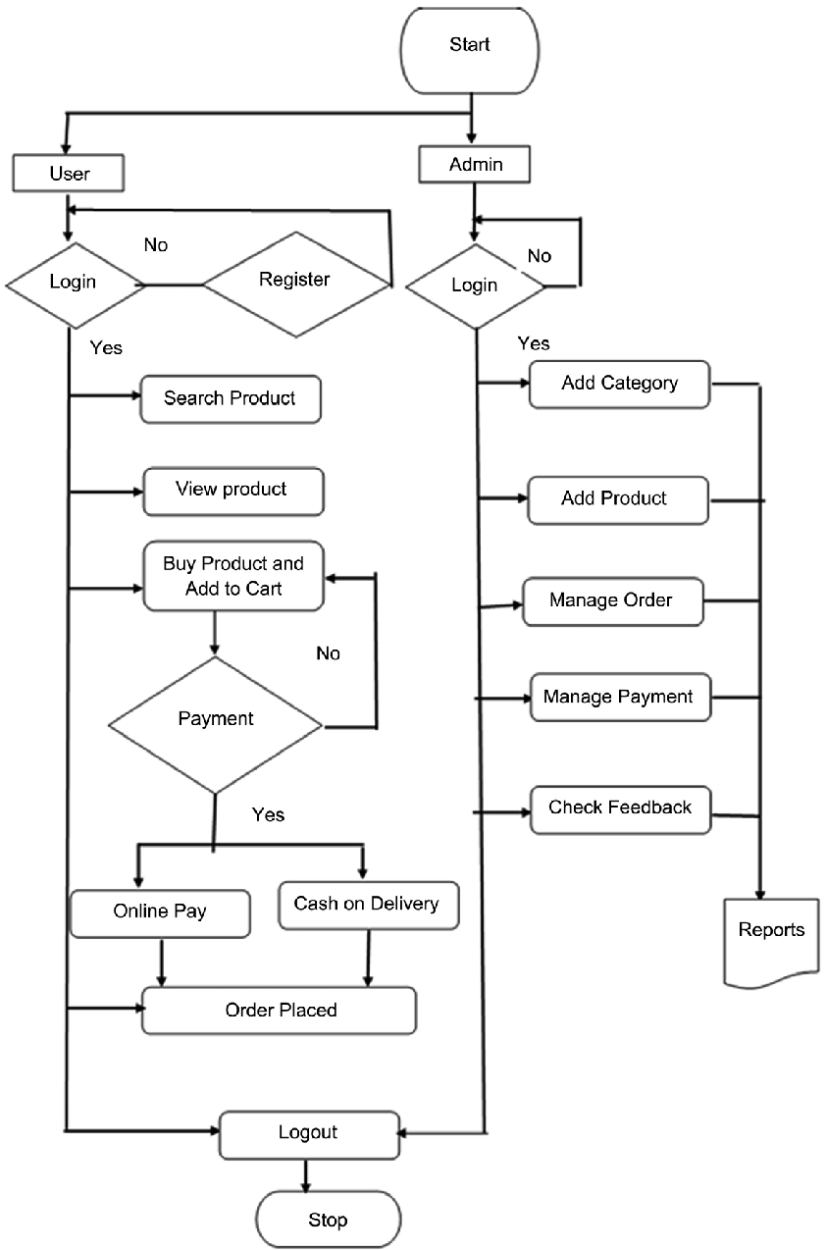

The Web is a service that operates over the Internet, just as email does. According to Microsoft, web technologies include the following: Mark-up languages, such as HTML, CSS, XML, CGI, and HTTP (Front-end or Client-side technologies) Programming languages and technologies that help create applications for the web.In this project we have used the following technologies HTML,CSS and JavaScrpit

**COMPANY PROFILE:**

Name of the company/organization: **BASKAR ADDS**

Address:**53/19,Pudhu Mohamathiar Street,Tiruchengode-637211**

PAN:**AHRPB9820F**

GSTIN:**33AHRPB9820FIZE**

VALUE OF PROJECT :**Rs.25,000/-**